Establish a new directory, populate it with script files, initiate an empty repository on GitHub, convert the local directory into a Git repository, and link it to GitHub for pushing the code into the repository. Perform merge, rebase, stash commands in following GitHub repo.

**Step 1:** Create a New Directory

**Step 2:** Create Script Files inside the new directory

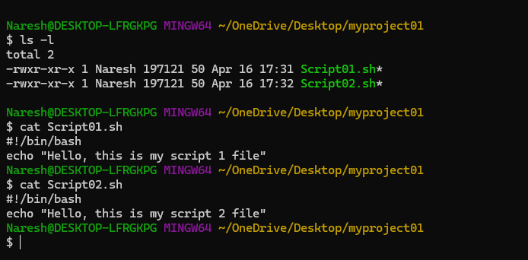

**Step 3:** Initiate an Empty Repository on GitHub

**Step 4:** Convert Local Directory into a Git Repository

**Step 5:** Add Remote Repository Link

**Step 6:** Stage and Committing my Changes and Push Code to GitHub Repository (master branch)

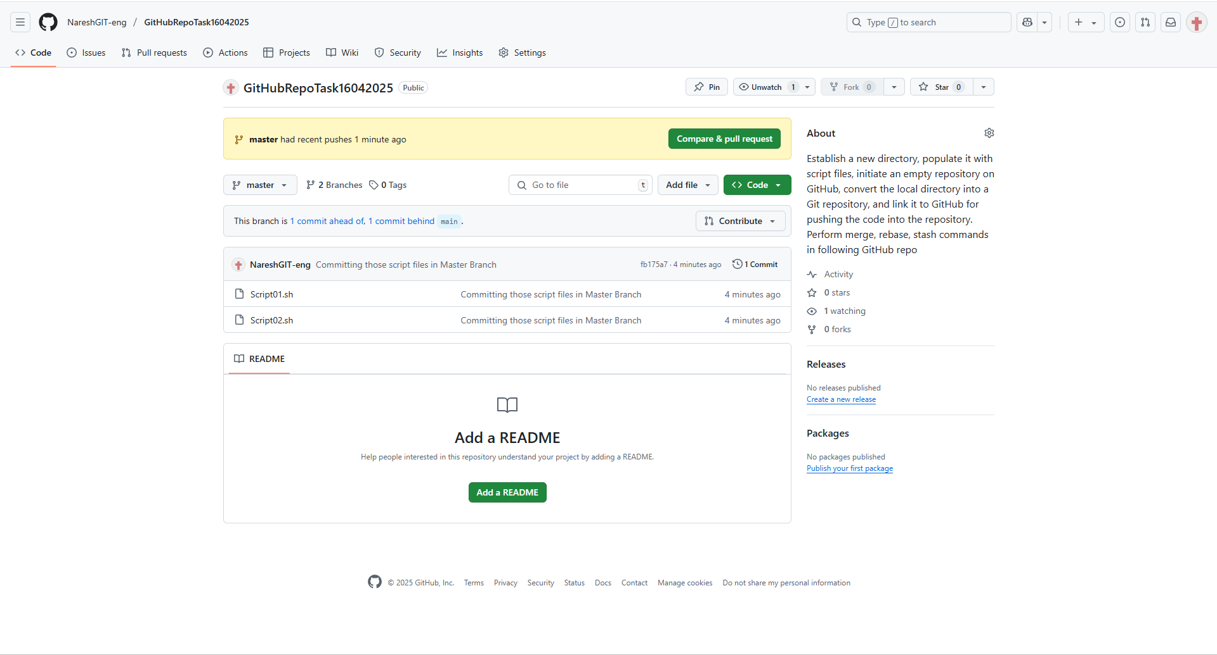

**Step 7:** Performing Merge, Rebase, and Stash Commands

**7a. Merge Command**

To demonstrate merging, intially creating another branch:

Now switch back to the main branch and merge

7b. Rebasing

7c. stash command

